 

|  |
| --- |
| FPT-aptech computer education |
| eProject Document |
| Excell-on Consulting Services (ECS) |
|  |
| |  |  | | --- | --- | | **Group 3- ECS** | | | **Group Member** | Hoang Phu Do - C00473 - 4368  Anh Tien Le - C00177 - 4372  Tung Minh Trinh - C00194 - 4545  Cuong Huy Pham - C00034 - 0554 | | **Instructor** | Vinh Le Duong | | **Batch** | C0812L | | **Semester** | 3 | |
|  |

|  |
| --- |
| - Hanoi, 06/2011 - |

Contents

1. Introduction 3

2. Problem Definition 3

2.1. Problem Abstraction 3

2.2. The Current System 3

2.3. The Proposed System 4

2.4. Boundaries of the System 4

2.5. Development Environment 4

3. Requirements and Business Flow 5

3.1. Customer Requirement Specification 5

3.2. Activity Diagram 6

3.3. Use Case Diagram 7

3.4. Use Case Specification 11

3.5. Other Concerns<Optional> 19

*4.* Design 19

4.1. System Architecture 19

4.2. Class Diagram 20

4.3. Class Diagram Explanation 20

4.4. Sequence Diagram (Optional) 20

4.5. Collaboration Diagram (Optional) 20

4.6. State Diagram (Optional) 20

4.7. Entity Relationship Diagram 20

4.8. Database Design 20

4.9. Algorithms (optional) 20

4.10. Others (optional) 20

5. System Prototype 21

6. Management and Project Planning 22

6.1. Management Approach 22

6.2. Project Plan 22

6.3. Task Sheet 22

6.4. Meeting Minutes (Optional) 22

7. Checklists 23

7.1. Check List of Validation 23

7.2. Submission Checklist 23

8. Screenshots 23

9. Coding Convention 23

10. Other Concerns<Optional> 23

Appendix 24

Glossary [Optional] 24

References [Optional] 24

Others<Optional> 24

# Introduction

This document contains the entire Excell-on Consulting Services project. It is organized into categories such as Problem Definition, Requirements and Business Flow, Design, System Prototype, Management and Project Planning, Checklists, Screenshots, Coding Convention…

# Problem Definition

## Problem Abstraction

Excell-on Consulting Services (ECS) helps organizations develop innovative business and commerce strategies and solutions. These solutions allow their (organizations, say clients of Excell-on Consulting Services) customers to capitalize on new technologies to create innovative products and services for the economy. Their consulting team stays focused on defining, optimizing, and aligning their client’s business and IT strategies.

## The Current System

Excell-on has segregated themselves into various branches based on the various services that they offer to their clients, so as to meet the requirements of organizations i.e., of their clients. The various branches that the Excell-on had segregated is as follows:

* In-bound Services (The In-bound service is a service in which one can only receive the calls from the customers. These call centers provide 24 hours service to all customers. The primary goal of these call centers are to receive product orders, help customers both technically and non-technically, to find dealer location.)
* Technical Support
* Customer Service
* Out-bound Services (The Out-bound service is a service in which the employees of Excell-on call the customers for product promotions, for checking with the customer satisfaction on the services they provide, and for the telemarketing. Outbound Call Centers depends on the technological solutions, extensive experience, quality assurance programs and commitment to customer service excellence that further ensures maximum results from the direct marketing efforts for its success.)
* Tele Marketing Services (The Tele Marketing service is a service which is purely for the promotion of marketing or sales of the products and services.)

## The Proposed System

As the Internet and the web being the growth engines of the new millennium, the management had decided to maintain the details of their services and that of their clients along with the services that they (clients of Excell-on) prefer, payment details. So they want an online application to be introduced into their system through which they can keep track of the services they provide, their clients, type of service that their client had preferred, and the products and the procedures of their clients and the details of the customers, and the call logs.

So they had approached us in order to help them by creating a web application for them meeting their requirements.

## Boundaries of the System

The system will be used by employees of Excell-on company.

## Development Environment

|  |  |  |
| --- | --- | --- |
|  | **Server** | **Client** |
| Hardware | * Ram 512 MB or larger  * CPU 2.0 Ghz or larger  * HDD 80 GB or larger  * Connect to internet | * Ram 128 Mb or larger  * CPU 266 MHZ or larger  * Connect to internet |
| Software | * Windows Server 2000 or later  * SQL Server 2005 or later  * IIS 6 or later | * Internet Explorer  * Firefox  * Chrome  * Safari |

*Deverloper tools*

* Microsoft Windows 2000 SP4 or higher
* Microsoft Visual Studio 2008
* Microsoft SQL Server 2005 Standard Edition or higher
* Net Framework 3.5
* Microsoft Office XP
* Microsoft Internet Explorer 7.0
* Adobe Dreamweaver CS5

# Requirements and Business Flow

## Customer Requirement Specification

The application should hold the following functionalities:

**► Non-Financial:**

1. The details of the services offered are to be maintained.
2. The different department details are to be maintained. The different departments that Excell-on has is as follows
   * HR Management
   * Administration
   * Service
   * Training
   * Internet Security (It will take care of any technical related issues and problems like PC of an employee is hanged, PC of an employee is not getting started, One of the software application is not running properly, installing and uninstalling software, etc.)
   * Auditors
3. The details of the employees are to be maintained based on the designation and the services (like out-bound, in-bound, etc.)
4. The details of the charges levied for each service are to be maintained.
5. The details of the clients are to be maintained.
6. The details of the services that their clients preferred are to be maintained.
7. The details of the products and services that their clients offer (like if the client is a manufacturer of refrigerators, then the details of the different type of refrigerator they manufacture are to be maintained, and if the client is the internet service provider, then the details like the various type of the services that they offer, and they want Excell-on to promote the sales services for that company using the in-bound or out-bound services, then these details are to be maintained, etc.) are to be maintained.
8. Based on the charges levied for a service, the total charges for the clients are to be calculated based on the services that the client prefers.
9. The details of the payments as received by the client are to be maintained.
10. The reports for the late payments, payments, clients, employees based on the services, for a particular duration are to be generated

**► Financial:**

The charges for the different services that they offer keep on varying based on the services preferred by their clients. The charge structure for the services that the Excell-on offers is as follows.

|  |  |  |
| --- | --- | --- |
| **Sr. No**. | **Service** | **Charges (per day per employee)** |
| 1 | In-bound | 4500$ |
| 2 | Out-bound | 6000$ |
| 3 | Tele Marketing | 5500$ |

***Functional Requirements:***

1. The database should contain the details of the services, department details, employee details, client details, the details of the services that are preferred by the clients, the product details of the clients, the payment details that are paid by the clients of Excell-on.
2. One should be able to maintain the details of the charges levied for each type of service.
3. One should be able to insert, update, delete and search and retrieve the records of the clients.
4. The advanced search option is to be implemented so as to fetch and retrieve the records.

## Activity Diagram

*<Business processes should be modeled carefully. Use activity diagrams to show important businesses. Focus on non-trivial ones>*

## Use Case Diagram

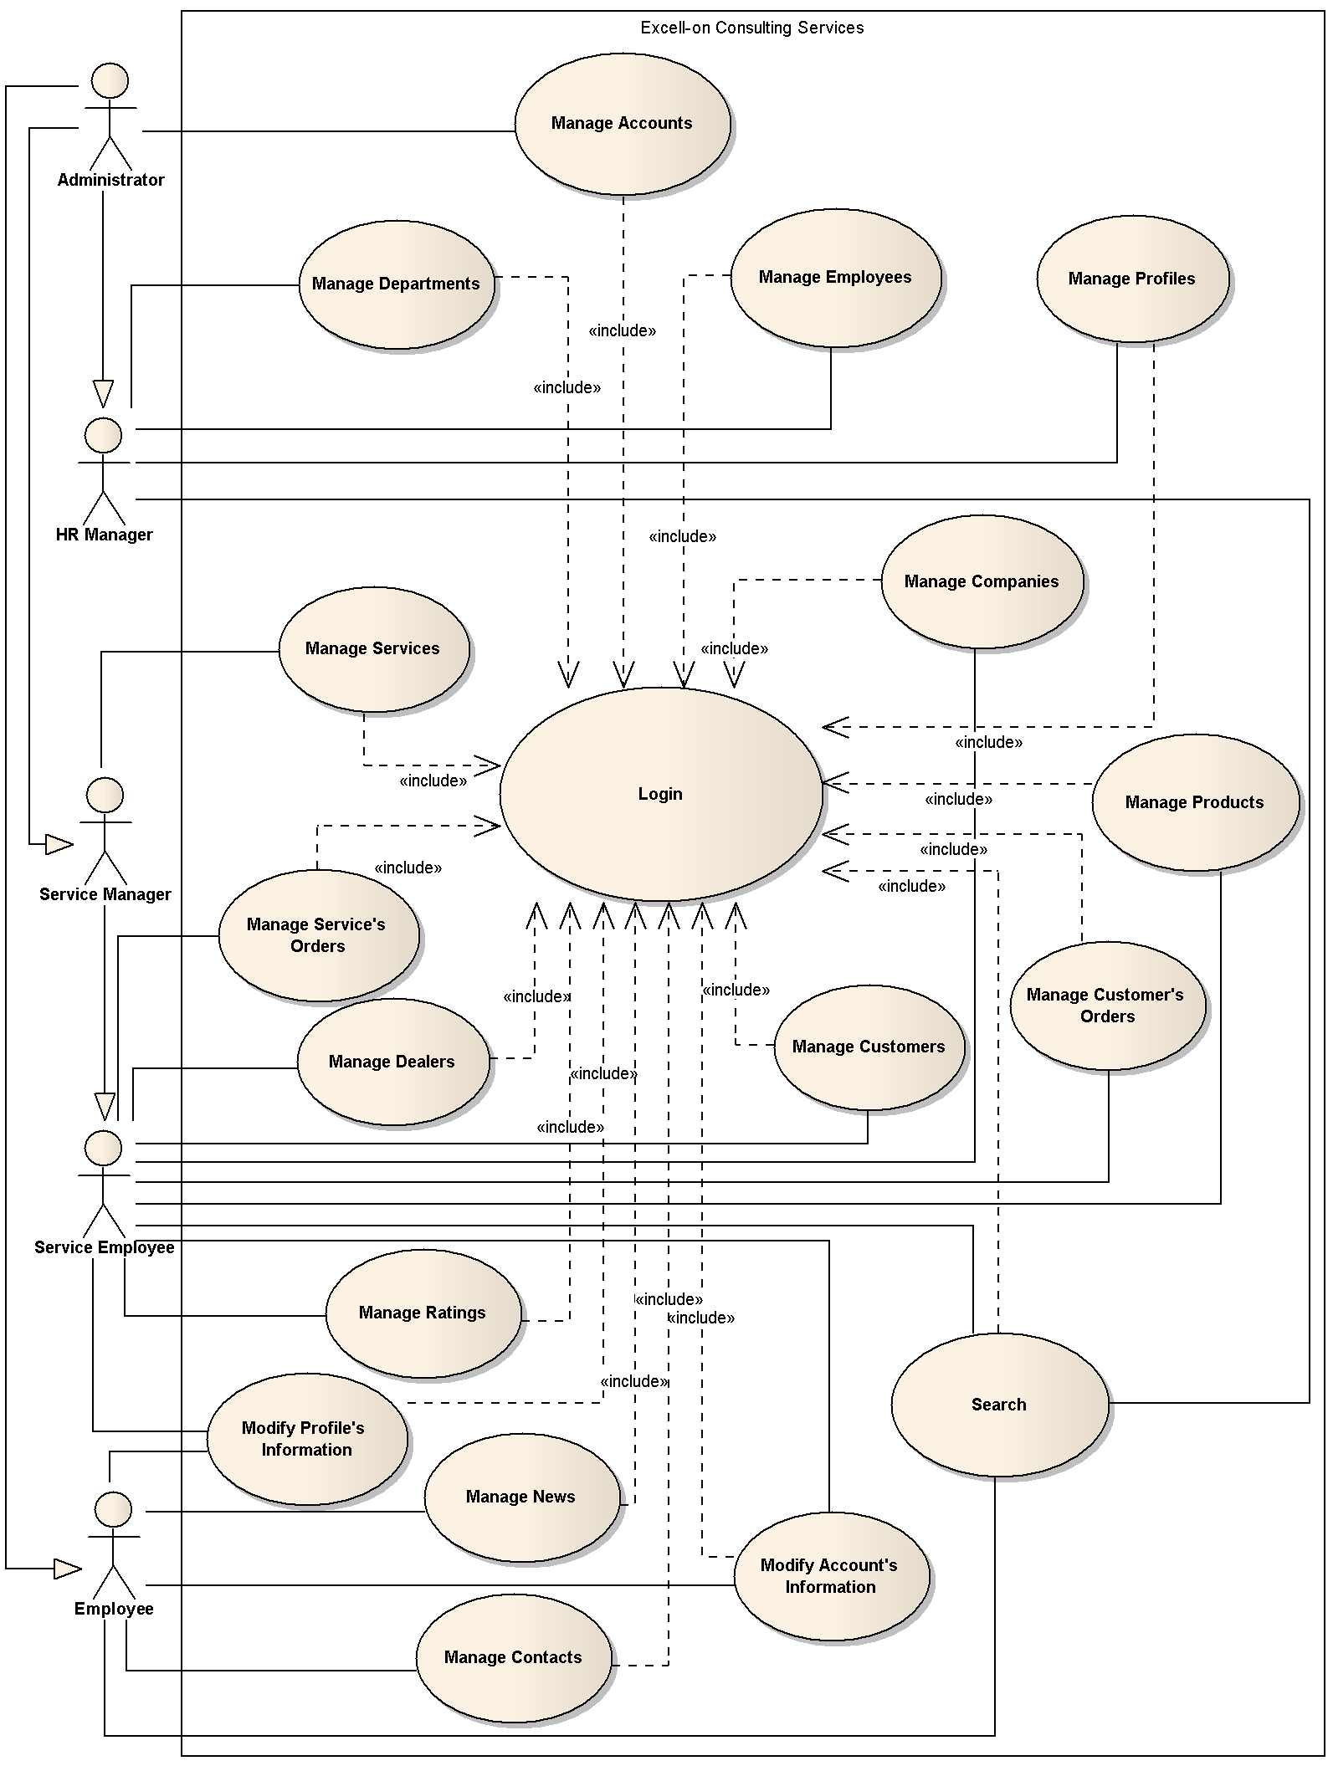

Figure 3.3.1 – Use case model ECS

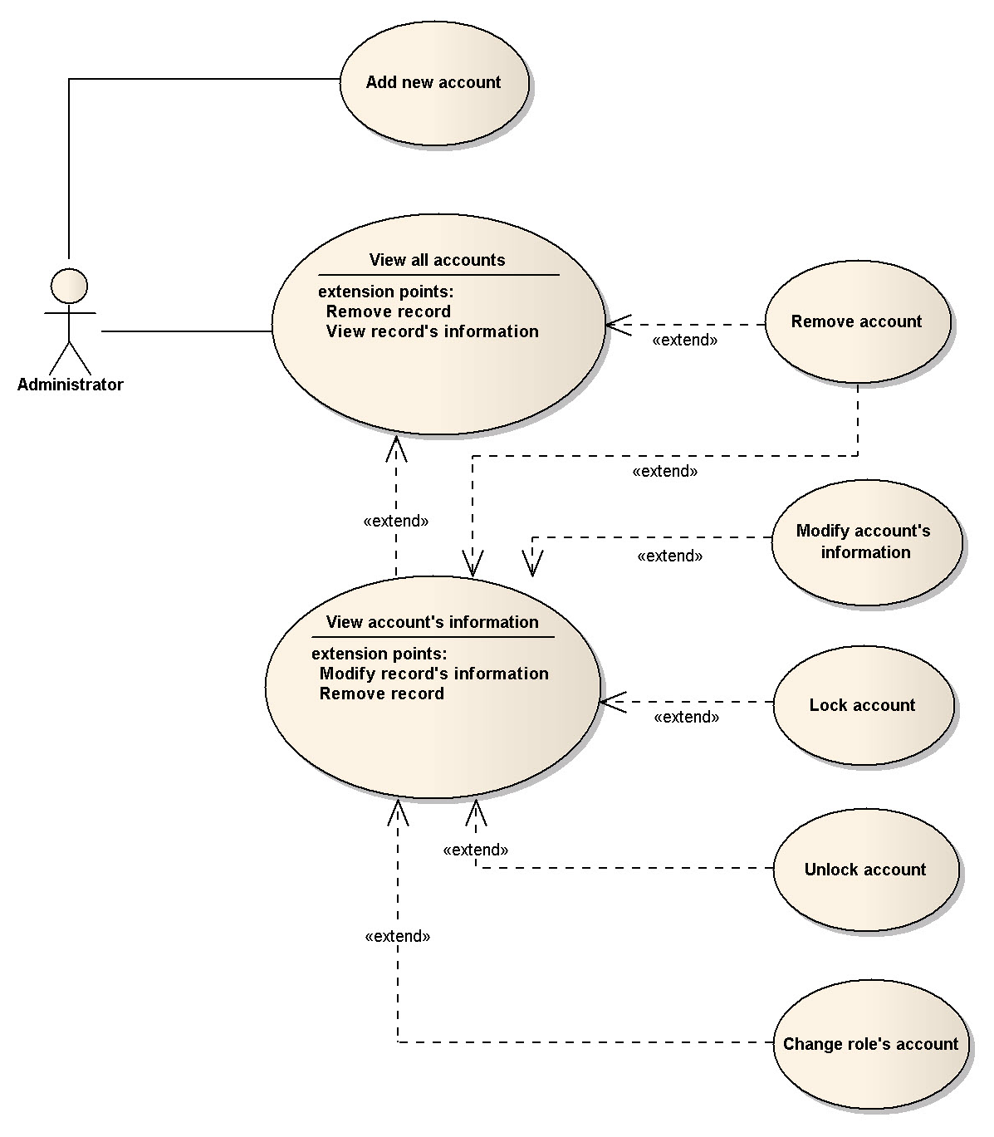

Figure 3.3.2 – Use case model Manage Account

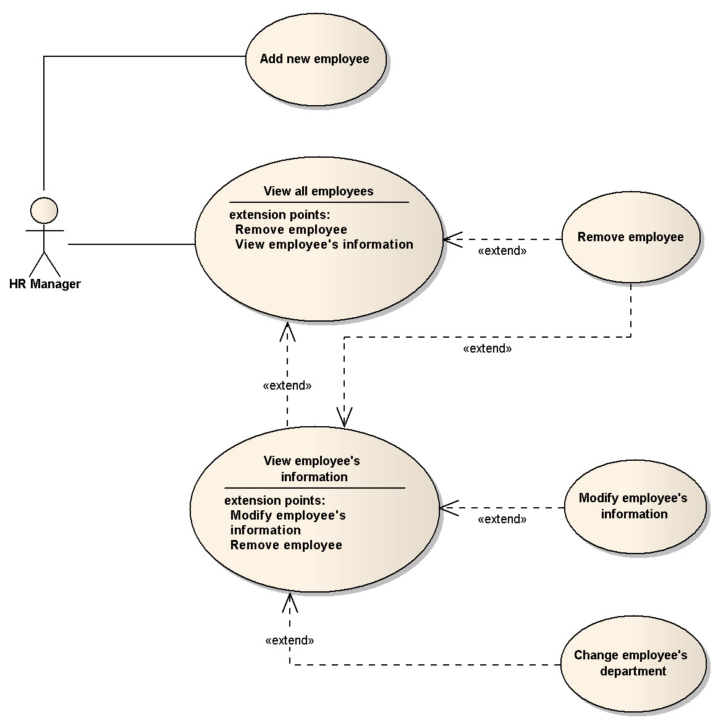

Figure 3.3.3 – Use case model Manage Employee

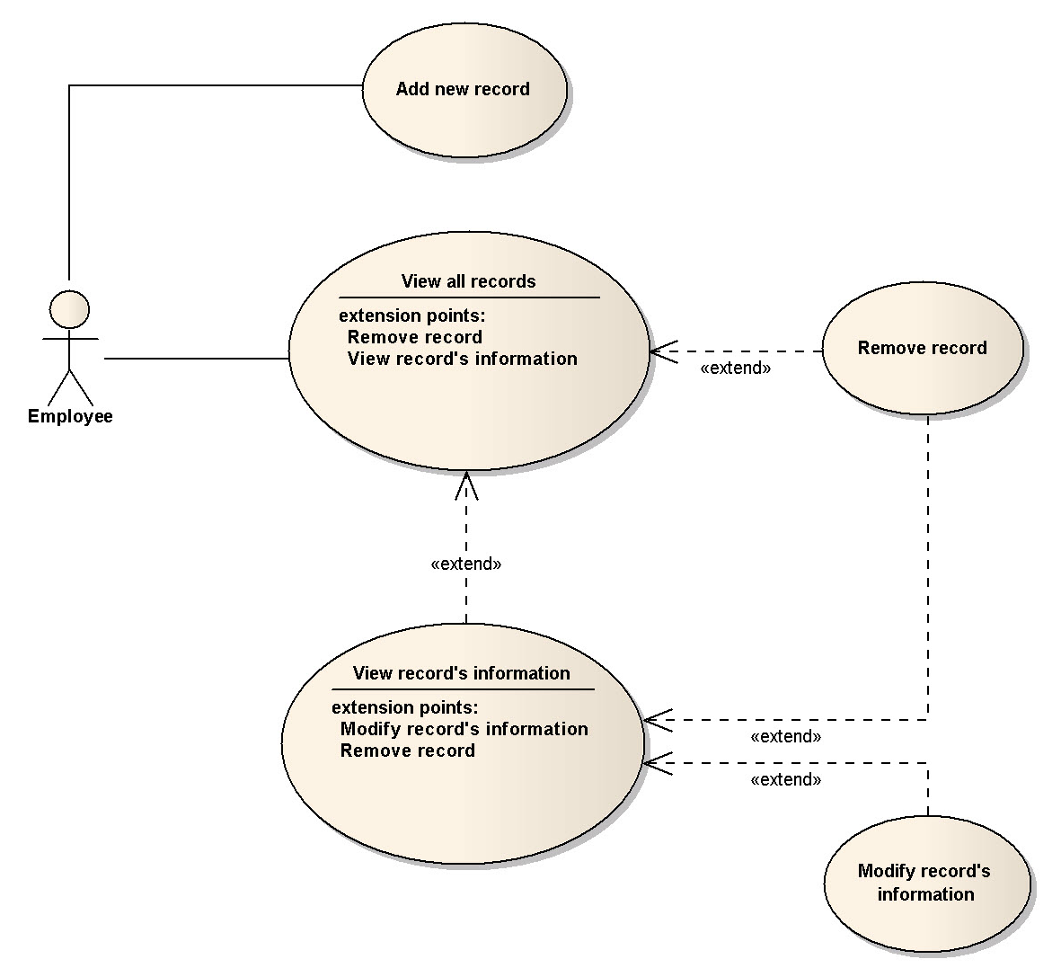

Figure 3.3.4 – Use case model Manage

## Use Case Specification

|  |  |  |  |  |
| --- | --- | --- | --- | --- |
| **USE CASE SPECIFICATION** | | | | |
| **Use-case No.** | UC001 | **Use-case Version** | | 1.0 |
| **Use-case Name** | Login | | | |
| **Author** | Hoang Phu Do | | | |
| **Date** | 24/04/2011 | **Priority** | High | |
| **Actor:**  - Administrator  - HR Manager  - Service Manager  - Service Employee  **Summary:**  *Checking the account’s validation to login to the system.*  **Goal:**  *- Checking the account’s validation*  **Triggers**    **Preconditions:**    **Post Conditions:**    **Main Success Scenario:**      **Alternative Scenario:**    **Exceptions:**    **Relationships:**    **Business Rules:** | | | | |

|  |  |  |  |  |
| --- | --- | --- | --- | --- |
| **USE CASE SPECIFICATION** | | | | |
| **Use-case No.** | UC002 | **Use-case Version** | | 1.0 |
| **Use-case Name** | Manage Accounts | | | |
| **Author** | Hoang Phu Do | | | |
| **Date** | 24/04/2011 | **Priority** | High | |
| **Actor:**  - Administrator  **Summary:**  *Manage employees’s account*  **Goal:**  *- Add new an account*  *- Modify account’s information*  *- Remove account*  *- Lock/ unlock account*  *- Change role for account*  *- View all accounts*  *- View account’s information*  **Triggers**    **Preconditions:**    **Post Conditions:**    **Main Success Scenario:**      **Alternative Scenario:**    **Exceptions:**    **Relationships:**    **Business Rules:** | | | | |

|  |  |  |  |  |
| --- | --- | --- | --- | --- |
| **USE CASE SPECIFICATION** | | | | |
| **Use-case No.** | UC003 | **Use-case Version** | | 1.0 |
| **Use-case Name** | Manage Employees | | | |
| **Author** | Hoang Phu Do | | | |
| **Date** | 24/04/2011 | **Priority** | High | |
| **Actor:**  - Administrator  - HR Manager  **Summary:**  *Manage employees’s information*  **Goal:**  *- Add new an employee*  *- Modify employee’s information*  *- Remove employee*  *- Change employee’s department*  *- View all employees*  *- View employee’s information*  **Triggers**    **Preconditions:**    **Post Conditions:**    **Main Success Scenario:**      **Alternative Scenario:**    **Exceptions:**    **Relationships:**    **Business Rules:** | | | | |

|  |  |  |  |  |
| --- | --- | --- | --- | --- |
| **USE CASE SPECIFICATION** | | | | |
| **Use-case No.** | UC004 | **Use-case Version** | | 1.0 |
| **Use-case Name** | Manage Departments | | | |
| **Author** | Hoang Phu Do | | | |
| **Date** | 24/04/2011 | **Priority** | Normal | |
| **Actor:**  - Administrator  - HR Manager  **Summary:**  *Manage departments’s information*  **Goal:**  *- Add new a department*  *- Modify department’s information*  *- Remove department*  *- View all departments*  *- View department’s information*  **Triggers**    **Preconditions:**    **Post Conditions:**    **Main Success Scenario:**      **Alternative Scenario:**    **Exceptions:**    **Relationships:**    **Business Rules:** | | | | |

|  |  |  |  |  |
| --- | --- | --- | --- | --- |
| **USE CASE SPECIFICATION** | | | | |
| **Use-case No.** | UC005 | **Use-case Version** | | 1.0 |
| **Use-case Name** | Manage Profiles | | | |
| **Author** | Hoang Phu Do | | | |
| **Date** | 24/04/2011 | **Priority** | High | |
| **Actor:**  - Administrator  - HR Manager  **Summary:**  *Manage profile’s information*  **Goal:**  *- Add new an profile*  *- Modify profile’s information*  *- Remove profile*  *- View profile’s information*  **Triggers**    **Preconditions:**    **Post Conditions:**    **Main Success Scenario:**      **Alternative Scenario:**    **Exceptions:**    **Relationships:**    **Business Rules:** | | | | |

|  |  |  |  |  |
| --- | --- | --- | --- | --- |
| **USE CASE SPECIFICATION** | | | | |
| **Use-case No.** | UC006 | **Use-case Version** | | 1.0 |
| **Use-case Name** | Manage Services | | | |
| **Author** | Hoang Phu Do | | | |
| **Date** | 24/04/2011 | **Priority** | High | |
| **Actor:**  - Administrator  - Service Manager  **Summary:**  *Manage Service’s information*  **Goal:**  *- Add new an service*  *- Modify service’s information*  *- Remove service*  *- View all services*  *- View service’s information*  **Triggers**    **Preconditions:**    **Post Conditions:**    **Main Success Scenario:**      **Alternative Scenario:**    **Exceptions:**    **Relationships:**    **Business Rules:** | | | | |

|  |  |  |  |  |
| --- | --- | --- | --- | --- |
| **USE CASE SPECIFICATION** | | | | |
| **Use-case No.** | UC007 | **Use-case Version** | | 1.0 |
| **Use-case Name** | Manage Dealers | | | |
| **Author** | Hoang Phu Do | | | |
| **Date** | 24/04/2011 | **Priority** | High | |
| **Actor:**  - Administrator  - Service Manager  - Service Employee  **Summary:**  *Manage dealer’s information*  **Goal:**  *- Add new a dealer*  *- Modify dealer’s information*  *- Remove dealer*  *- View all dealers*  *- View dealer’s information*  **Triggers**    **Preconditions:**    **Post Conditions:**    **Main Success Scenario:**      **Alternative Scenario:**    **Exceptions:**    **Relationships:**    **Business Rules:** | | | | |

|  |  |  |  |  |
| --- | --- | --- | --- | --- |
| **USE CASE SPECIFICATION** | | | | |
| **Use-case No.** | UC008 | **Use-case Version** | | 1.0 |
| **Use-case Name** | Manage Companies | | | |
| **Author** | Hoang Phu Do | | | |
| **Date** | 24/04/2011 | **Priority** | Normal | |
| **Actor:**  - Administrator  - Service Manager  - Service Employee  **Summary:**  *Manage companies’s information*  **Goal:**  *- Add new a company*  *- Modify company’s information*  *- Remove company*  *- View all companies*  *- View company’s information*  **Triggers**    **Preconditions:**    **Post Conditions:**    **Main Success Scenario:**      **Alternative Scenario:**    **Exceptions:**    **Relationships:**    **Business Rules:** | | | | |

|  |  |  |  |  |
| --- | --- | --- | --- | --- |
| **USE CASE SPECIFICATION** | | | | |
| **Use-case No.** | UC009 | **Use-case Version** | | 1.0 |
| **Use-case Name** | Manage Products | | | |
| **Author** | Hoang Phu Do | | | |
| **Date** | 24/04/2011 | **Priority** | Normal | |
| **Actor:**  - Administrator  - Service Manager  - Service Employee  **Summary:**  *Manage products’s information*  **Goal:**  *- Add new a product*  *- Modify products’s information*  *- Remove product*  *- View all products*  *- View product’s information*  **Triggers**    **Preconditions:**    **Post Conditions:**    **Main Success Scenario:**      **Alternative Scenario:**    **Exceptions:**    **Relationships:**    **Business Rules:** | | | | |

|  |  |  |  |  |
| --- | --- | --- | --- | --- |
| **USE CASE SPECIFICATION** | | | | |
| **Use-case No.** | UC010 | **Use-case Version** | | 1.0 |
| **Use-case Name** | Manage Service Orders | | | |
| **Author** | Hoang Phu Do | | | |
| **Date** | 24/04/2011 | **Priority** | Normal | |
| **Actor:**  - Administrator  - Service Manager  - Service Employee  **Summary:**  *Manage Service Orders’s information*  **Goal:**  *- Add new a service order*  *- Modify service order’s information*  *- Remove service order*  *- View all service orders*  *- View service order’s information*  **Triggers**    **Preconditions:**    **Post Conditions:**    **Main Success Scenario:**      **Alternative Scenario:**    **Exceptions:**    **Relationships:**    **Business Rules:** | | | | |

|  |  |  |  |  |
| --- | --- | --- | --- | --- |
| **USE CASE SPECIFICATION** | | | | |
| **Use-case No.** | UC011 | **Use-case Version** | | 1.0 |
| **Use-case Name** | Manage Customer Orders | | | |
| **Author** | Hoang Phu Do | | | |
| **Date** | 24/04/2011 | **Priority** | Normal | |
| **Actor:**  - Administrator  - Service Manager  - Service Employee  **Summary:**  *Manage customer order’s information*  **Goal:**  *- Add new a customer order*  *- Modify customer order’s information*  *- Remove customer order*  *- View all customer orders*  *- View customer order’s information*  **Triggers**    **Preconditions:**    **Post Conditions:**    **Main Success Scenario:**      **Alternative Scenario:**    **Exceptions:**    **Relationships:**    **Business Rules:** | | | | |

|  |  |  |  |  |
| --- | --- | --- | --- | --- |
| **USE CASE SPECIFICATION** | | | | |
| **Use-case No.** | UC012 | **Use-case Version** | | 1.0 |
| **Use-case Name** | Manage News | | | |
| **Author** | Hoang Phu Do | | | |
| **Date** | 24/04/2011 | **Priority** | Low | |
| **Actor:**  - Administrator  - Employee  **Summary:**  *Manage news’s information*  **Goal:**  *- Add new a news*  *- Modify news’s information*  *- Remove news*  *- View all newses*  *- View news’s information*  **Triggers**    **Preconditions:**    **Post Conditions:**    **Main Success Scenario:**      **Alternative Scenario:**    **Exceptions:**    **Relationships:**    **Business Rules:** | | | | |

|  |  |  |  |  |
| --- | --- | --- | --- | --- |
| **USE CASE SPECIFICATION** | | | | |
| **Use-case No.** | UC013 | **Use-case Version** | | 1.0 |
| **Use-case Name** | Manage Contacts | | | |
| **Author** | Hoang Phu Do | | | |
| **Date** | 24/04/2011 | **Priority** | Low | |
| **Actor:**  - Administrator  - Employee  **Summary:**  *Manage contact’s information*  **Goal:**  *- Add new a contact*  *- Modify contact’s information*  *- Remove contact*  *- View all contacts*  *- View contact’s information*  **Triggers**    **Preconditions:**    **Post Conditions:**    **Main Success Scenario:**      **Alternative Scenario:**    **Exceptions:**    **Relationships:**    **Business Rules:** | | | | |

|  |  |  |  |  |
| --- | --- | --- | --- | --- |
| **USE CASE SPECIFICATION** | | | | |
| **Use-case No.** | UC014 | **Use-case Version** | | 1.0 |
| **Use-case Name** | Manage Ratings | | | |
| **Author** | Hoang Phu Do | | | |
| **Date** | 24/04/2011 | **Priority** | Normal | |
| **Actor:**  - Administrator  - Service Manager  - Service Employee  **Summary:**  *Manage rating’s information*  **Goal:**  *- Add new a rating*  *- Modify rating’s information*  *- Remove rating*  *- View all ratings*  *- View rating’s information*  **Triggers**    **Preconditions:**    **Post Conditions:**    **Main Success Scenario:**      **Alternative Scenario:**    **Exceptions:**    **Relationships:**    **Business Rules:** | | | | |

|  |  |  |  |  |
| --- | --- | --- | --- | --- |
| **USE CASE SPECIFICATION** | | | | |
| **Use-case No.** | UC015 | **Use-case Version** | | 1.0 |
| **Use-case Name** | Modify Profile’s Information | | | |
| **Author** | Hoang Phu Do | | | |
| **Date** | 24/04/2011 | **Priority** | Low | |
| **Actor:**  - Administrator  - HR Manager  - Service Manager  - Service Employee  - Employee  **Summary:**  *Modify profile’s* *information*  **Goal:**  *- Modify profile’s* *information*  **Triggers**    **Preconditions:**    **Post Conditions:**    **Main Success Scenario:**      **Alternative Scenario:**    **Exceptions:**    **Relationships:**    **Business Rules:** | | | | |

|  |  |  |  |  |
| --- | --- | --- | --- | --- |
| **USE CASE SPECIFICATION** | | | | |
| **Use-case No.** | UC016 | **Use-case Version** | | 1.0 |
| **Use-case Name** | Modify Account’s Information | | | |
| **Author** | Hoang Phu Do | | | |
| **Date** | 24/04/2011 | **Priority** | Low | |
| **Actor:**  - Administrator  - HR Manager  - Service Manager  - Service Employee  - Employee  **Summary:**  *Modify account’s information*  **Goal:**  *- Modify account’s information*  **Triggers**    **Preconditions:**    **Post Conditions:**    **Main Success Scenario:**      **Alternative Scenario:**    **Exceptions:**    **Relationships:**    **Business Rules:** | | | | |

|  |  |  |  |  |
| --- | --- | --- | --- | --- |
| **USE CASE SPECIFICATION** | | | | |
| **Use-case No.** | UC017 | **Use-case Version** | | 1.0 |
| **Use-case Name** | Manage Customers | | | |
| **Author** | Hoang Phu Do | | | |
| **Date** | 24/04/2011 | **Priority** | Normal | |
| **Actor:**  - Administrator  - Service Manager  - Service Employee  **Summary:**  *Manage customer’s information*  **Goal:**  *- Add new a customer*  *- Modify customer’s information*  *- Remove customer*  *- View all customers*  *- View customer’s information*  **Triggers**    **Preconditions:**    **Post Conditions:**    **Main Success Scenario:**      **Alternative Scenario:**    **Exceptions:**    **Relationships:**    **Business Rules:** | | | | |

|  |  |  |  |  |
| --- | --- | --- | --- | --- |
| **USE CASE SPECIFICATION** | | | | |
| **Use-case No.** | UC018 | **Use-case Version** | | 1.0 |
| **Use-case Name** | Search | | | |
| **Author** | Hoang Phu Do | | | |
| **Date** | 24/04/2011 | **Priority** | Low | |
| **Actor:**  - Administrator  - HR Manager  - Service Manager  - Service Employee  - Employee  **Summary:**  *Search any information in the system*  **Goal:**  *- The details of the services offered.*  *- The details of employees, department, companies, products, ect…*  *- The payment details that are paid by the clients of Excell-on*  **Triggers**    **Preconditions:**    **Post Conditions:**    **Main Success Scenario:**      **Alternative Scenario:**    **Exceptions:**    **Relationships:**    **Business Rules:** | | | | |

## Other Concerns<Optional>

# Design

## System Architecture

## 3tier.png

Figure 4.1.1 – Three tier web model

* Application layer is the form where we design using the controls like textbox, labels, command buttons etc.
* Business layer is the class where we write the functions which get the data from the application layer and passes through the data access layer.
* Data layer is also the class which gets the data from the business layer and sends it to the database or gets the data from the database and sends it to the business layer.
* Property layer is the sub layer of the business layer in which we make the properties to sent or get the values from the application layer. These properties help to sustain the value in a object so that we can get these values till the object destroy.

## Class Diagram

*<Provide class diagrams for the project>*

## Class Diagram Explanation

*<Provide brief explanation about the class diagram above. You do not need to explain “obvious” parts of your class diagram. For example, I know what a “Login” class is. Don’t say “The login class was created to store login information.”>*

## Sequence Diagram (Optional)

*<for important and complex interactions, protocols or algorithms, sequence diagrams should be drawn for clearing the details and supporting the system implementation. This section is optional>*

## Collaboration Diagram (Optional)

*<for important and complex interactions, collaboration diagrams should be drawn for clearing the details and supporting the system implementation. This section is optional>*

## State Diagram (Optional)

*<put all state diagrams here>*

## Entity Relationship Diagram

## ER-Diagram-Full.png

## Database Design

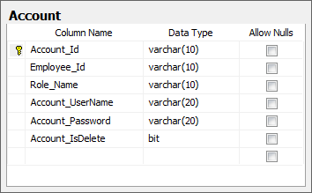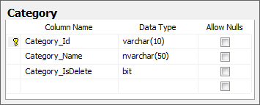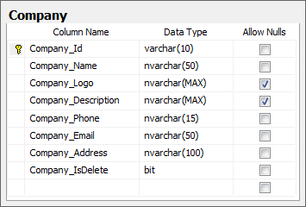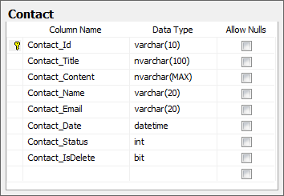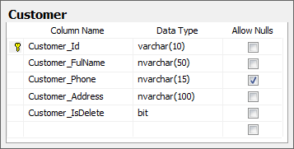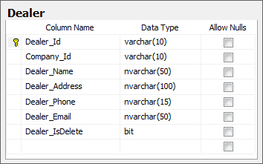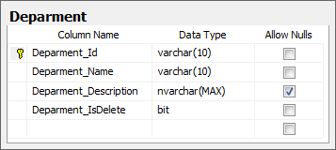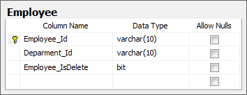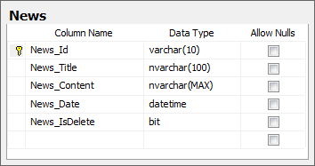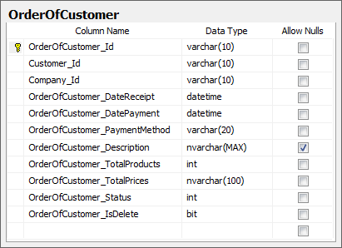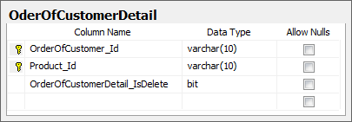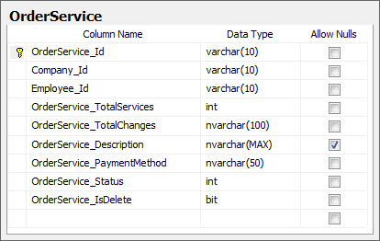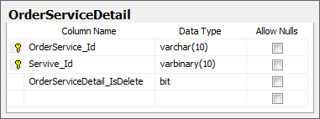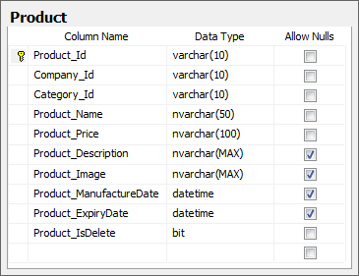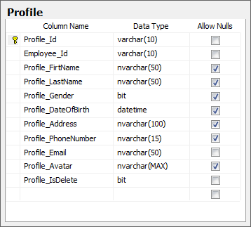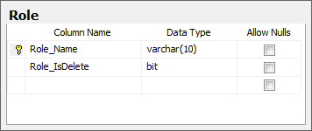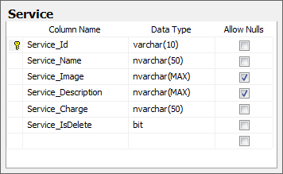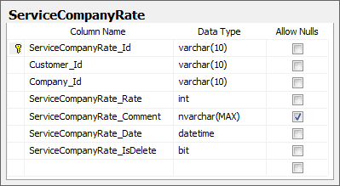

## Algorithms (optional)

*<Provide the detailed description about algorithms used in the system. You can use Flow Chart or Activity Diagram to represent algorithms. Focus on the important and complex algorithms>*

## Others (optional)

*<Any design concerns or diagrams can be put here>*

# System Prototype

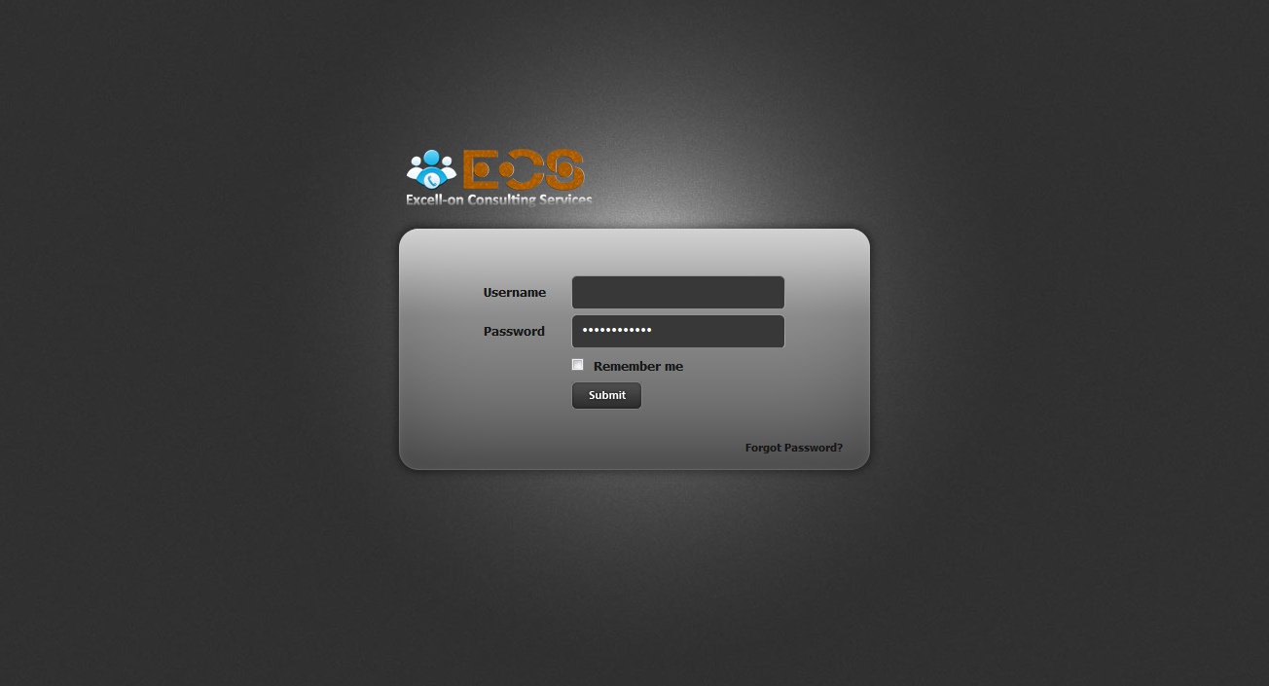

Figure 5.1 – Login Form

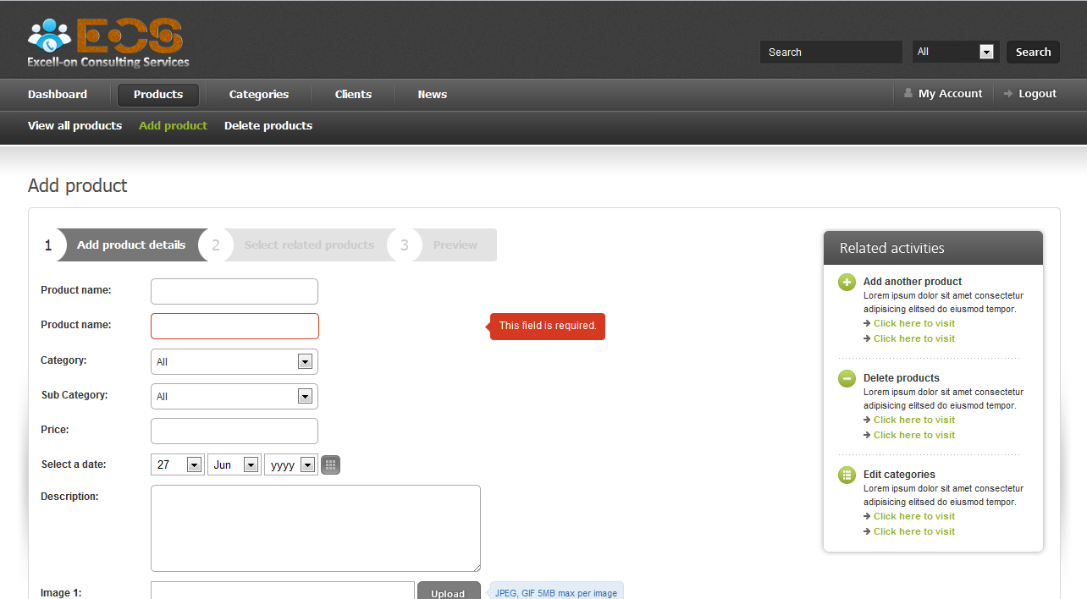

Figure 5.2 – Insert Form

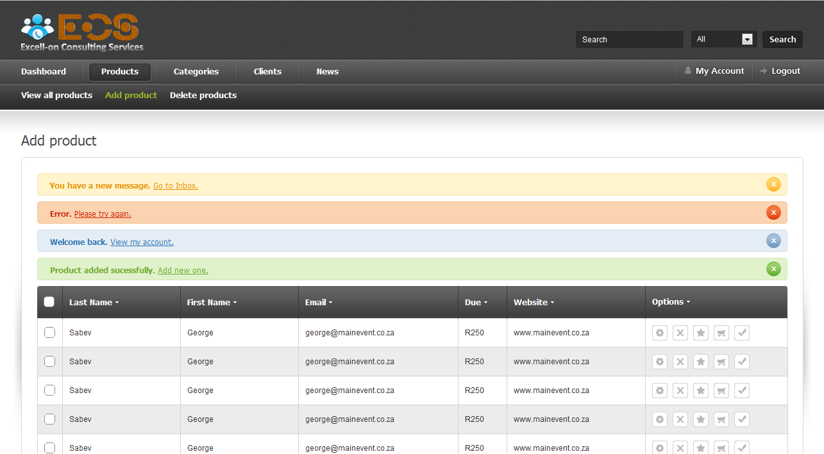

Figure 5.3 – Manage Form

# Management and Project Planning

## Management Approach

*< Briefly describe the management approach that your team selects. Is your team self-managed or managed by one leader? How do you assign tasks to team members? How often do you meet? What do you do during meeting? Etc.>*

## Project Plan

*<The detailed project plan is put here. You can use WBS Excel sheet, Sprint Backlog, Task sheet, Gantt chart, etc. to present your team’s plan. You can capture the Gantt chart in PMS if you use it to plan your project>*

## Task Sheet

*<Write down the tasks in Task Sheet maner; see eProject Guide for detailed Task Sheet>*

## Meeting Minutes (Optional)

*<Put all minutes of your team meetings here>*

# Checklists

## Check List of Validation

*< Put the checklist here; describe how it is used and the resulted checklist>*

## Submission Checklist

*< Put the checklist here; describe how it is used and the resulted checklist>*

# Screenshots

*<Capture some intuitive and main screens of the software and put them here>*

# Coding Convention

*<Provide the coding convention for your team. If you simply want to use the existing code standard(s) such as ‘Java Code Convention’, you can refer to it\them by name or URL>*

# Other Concerns<Optional>

*<If you have any other information you want to add to this document, place it here. This could include thoughts on the eProject, improvements, etc.>*

# Appendix

## Glossary [Optional]

*<Place all definitions or abbreviation used in this document >*

## References [Optional]

*<Place all referenced materials used in this document >*

## Others<Optional>